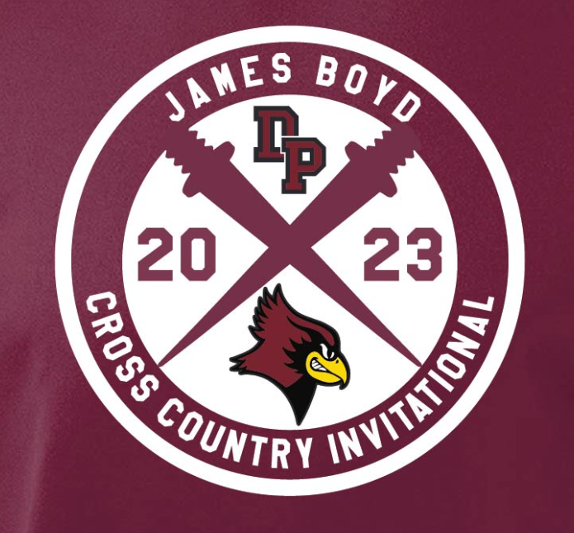
De Pere Redbirds James Boyd Cross Country Invitational - UW-Green Bay CC Course
Thursday, August 31, 2023
LOCATION: 2532 Shorewood Dr, Green Bay, WI 54311
Participating Schools: Appleton East, Ashwaubenon, Bay Port, De Pere, Freedom, Gillett, Green Bay East, Green Bay Southwest, Green Bay West, Hartford Union, Kewuanee, Kohler, Laconia, Laona-Wabeno, Lena, Luxemburg-Casco, Manitowoc Lincoln, Manitowoc Lutheran, Mukwonago, New London, Oconto Falls, Peshtigo, Plymouth, Pulaski, Sevastopol, Seymour, Shawano, Waterford, Wausau West, West De Pere, Winnebago Lutheran Academy, Winneconne, Wrightstown

Entry Fee: $165 - please mail in prior to 8/31/23 or deliver at the meet - make checks payable to: De Pere High School

Head Coaches: Chris Hendricks (chendricks@depere.k12.wi.us) and Jackie Joseph (jjoseph@depere.k12.wi.us)

Timing/Scoring Information:
- OnYourMarks Timing will be timing and scoring the meet.
- Team should enter their athletes at Athletic.net - Go to Athletic.net > Search (upper right corner) for De Pere Invitational > To register login or create a free account > Once an account is created you will be able to upload your team
  - QUESTIONS RELATED TO ENTERING YOUR TEAM should be directed to Mark Messer: mwmesser@gmail.com
- All entries are due by Tuesday, August 29, 2023, at 7:00 PM.
- Each runner will receive an RFID shoe tag, along with a bib to wear
  - Lost RFID shoe tags will be billed to the team at the cost of $15/tag
- Varsity is limited to 8 runners per team
- JV is unlimited entries
- Results will be live at the OnYourMarksTiming.com timing website
- Scoring: standard scoring - top 5 runners from each team in each race, ties broken by 6, 7, and 8 runners (in that order)
  - Scoring will be divided up between large and small schools for each race (see divisions below)
- Awards:
  - Medals to top 10 boys and girls OVERALL varsity runners
  - Medals to top 10 boys and girls OVERALL JV runners
  - 1st place plaque to boys and girls large school varsity team champion
  - 1st place plaque to boys and girls small school varsity team champion
- Final results will be posted on Athletic.net and emailed out to all coaches

Coaches Meeting: 3:30 near the start/finish line

Meet Officials: Bruce Zellner and Don Tolkacz

Jury of Appeals: Head Coaches from: Gillett, Seymour, Winneconne
Athletic Trainer: An Aurora athletic trainer will be onsite prior to the meet starting and then for the duration of the meet. They will be located near the start/finish line.

Race Times:
- Brief Re-Naming Ceremony - 3:40
- Girls JV - 4:00 - unlimited entries
- Boys JV - 4:40 - unlimited entries
- Girls Varsity - 5:20 - 8 entries only
- Boys Varsity - 5:50 - 8 entries only
**race times may be pushed back due to weather and/or if runners are still on the course**

Course:
- 5K course that weaves and rolls through the old Shorewood Golf Course at UWGB - expect rolling hills for this course, with an uphill finish - map is attached at the end of this document
- The course will be marked with white lines on both sides and directional markers as needed - volunteers will be on the course at any areas that may need additional directional guidance
- There will be a lead vehicle guiding the front of the race, as well as a follow vehicle trailing the final runner

Awards Ceremony: There will be a brief ceremony following the conclusion of the final race after scores have been compiled.

Parking:
- Please park in the Weidner Center Parking lot. There will be plenty of room for buses and spectators. The Outdoor Adventure Center parking lot will not be open for parking.

Team Camp
- Teams can set up their tents/camps across the parking lot in the designated “Tent City”. There will be some garbage receptacles, but please have your team bag up their garbage prior to leaving.
Bathrooms:
- There will be porta-potties available for use near the start/finish of the course. The Outdoor Adventure Center will not be available for bathrooms.

Concessions/T-Shirts: CASH ONLY
- UWGB will be selling concessions at the meet
- De Pere Invite T-shirts will be available at the concession stand for $15 - sizes will be limited to what is available - see design at the top of the information page

Questions:
If you have any questions please initially reach out to either:
- Chris Hendricks - (920) 227-7905 - chendricks@depere.k12.wi.us
- Jackie Joseph - (920) 265-5841 - jjoseph@depere.k12.wi.us
- Jeff Byczek, AD - (920) 983-9174 x 4012 (jbyczek@depere.k12.wi.us)

Top Five Course Times:
Girls | Boys
19:17.8 - Hope Dragseth - De Pere - ‘22  19:37.9 - Kate Schmoll - West De Pere - ‘22  20:05.1 - Emma Coon - De Pere - ‘22  21:38.9 - Lilly Guenther - Shawano - ‘22  21:50.6 - Reese Gustafson - Bay Port - ‘22 | 16:22.8 - Noah Jahnke - West De Pere - ‘22  16:36.7 - Alex Peterson - Gillett - ‘22  16:47.8 - Grady Lenn - De Pere - ‘22  17:07.8 - Ethan Onesti - Shawano - ‘22  17:20.5 - Matthew Schmoll - West De Pere - ‘22
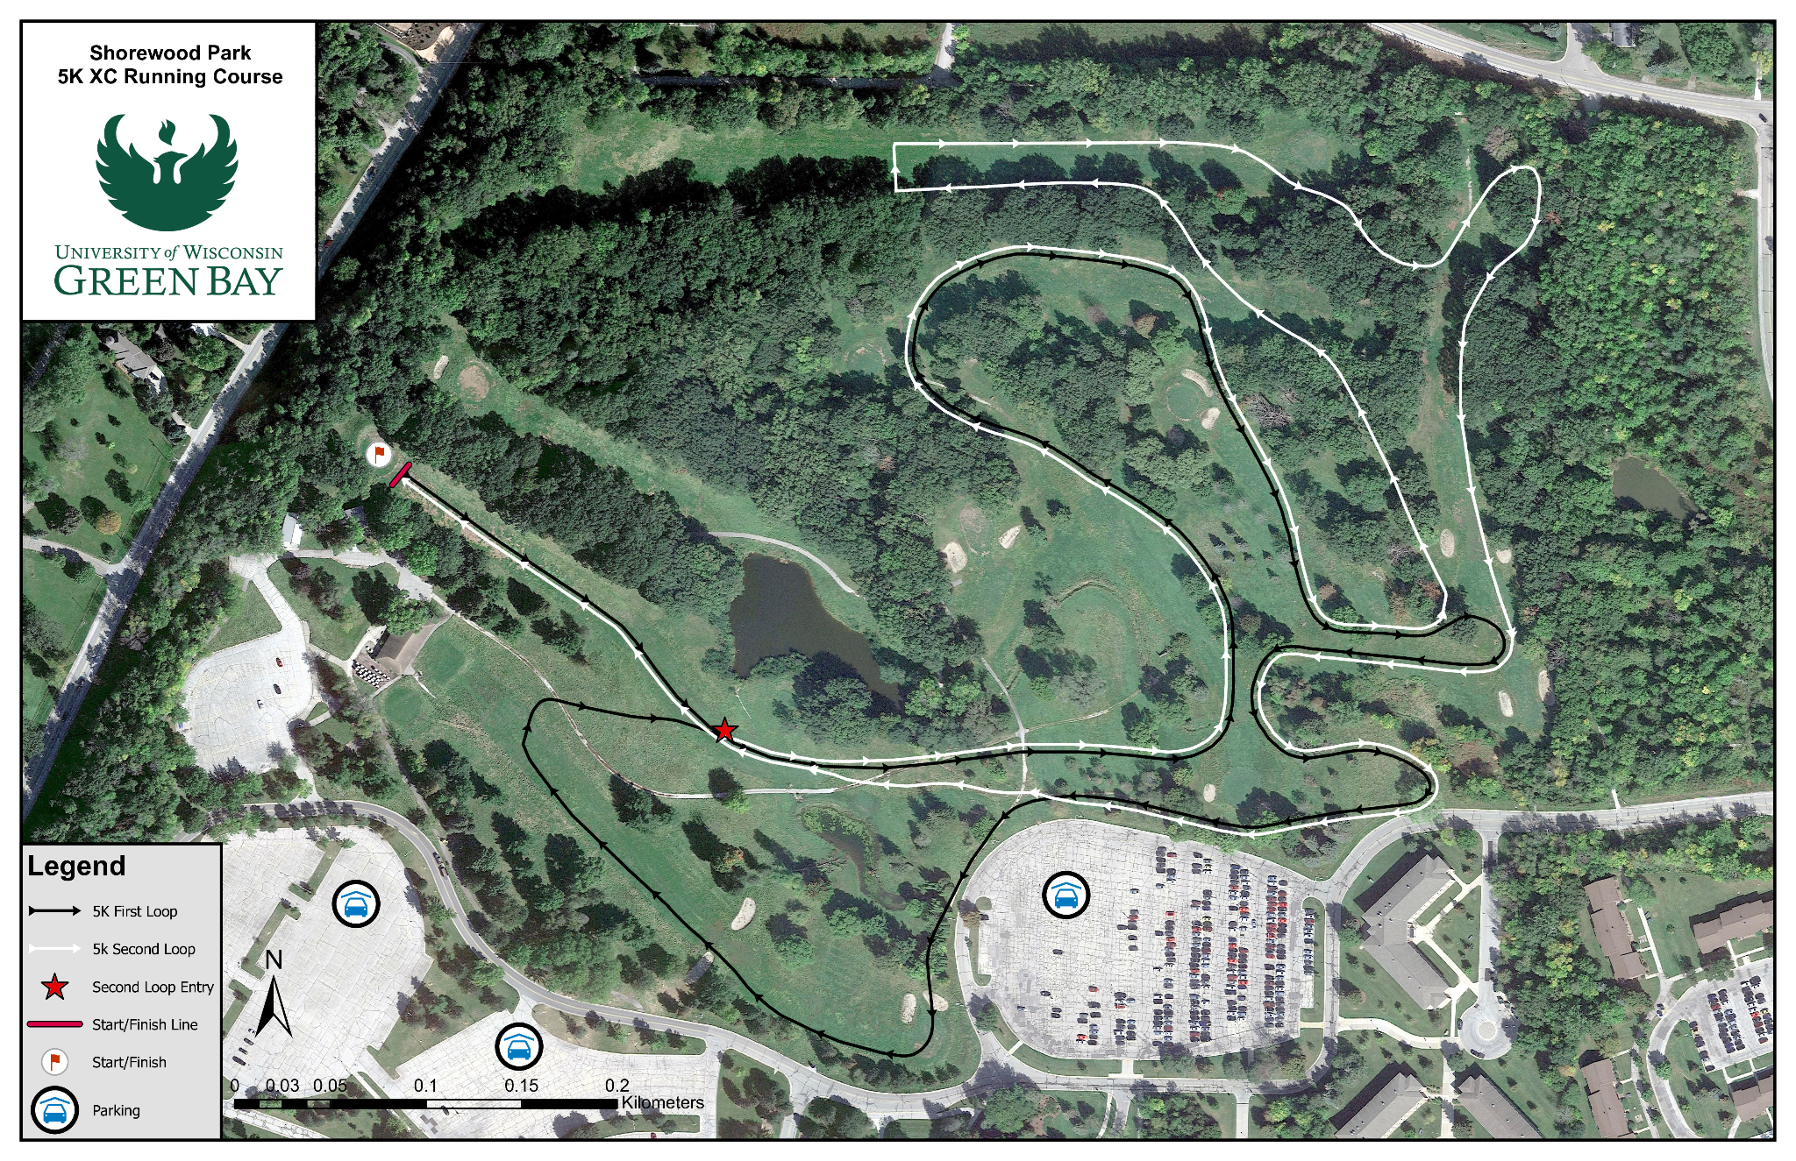
Lane Assignments:
1 | 2 | 3 | 4 | 5 | 6
Appleton East | Lena | Kohler | Wausau West | West De Pere | Shawano
7 | 8 | 9 | 10 | 11 | 12
Laconia | Seymour | Laona-  Wabeno | De Pere | Sevastopol | Ashwaubenon
13 | 14 | 15 | 16 | 17 | 18
Gillett | Plymouth | Winnebago Luthern | Pulaski | Wrightstown | Green Bay West
19 | 20 | 21 | 22 | 23 | 24
Hartford Union | Waterford | Peshtigo | Mukwonago | Green Bay Southwest | Kewaunee
25 | 26 | 27 | 28 | 29 | 30
Winneconne | New London | Manitowoc Lutheran | Bay Port | Freedom | Manitowoc Lincoln
31 | 32 | 33
Green Bay East | Oconto Falls | Luxemburg-  Casco

Divisions were determined by school enrollment and then splitting the total number of teams in half.
Small School Division | Large School Division
Lena (138)  Laona-Wabeno (167)  Gillett (168)  Sevastopol (176)  Manitowoc Lutheran (216)  Kohler (217)  Winnebago Lutheran Academy (304)  Laconia (311)  Kewaunee (319)  Peshtigo (332)  Wrightstown (427)  Oconto Falls (490)  Freedom (521)  Winneconne (522)  Luxemburg-Casco (601)  Seymour (686)  New London (731) | Plymouth (739)  Shawano (805)  Green Bay West (876)  Waterford (984)  Ashwaubenon (1,013)  West De Pere (1,042)  Pulaski (1,161)  Green Bay Southwest (1,220)  Green Bay East (1,297)  Hartford Union (1,320)  De Pere (1,455)  Manitowoc Lincoln (1,527)  Wausau West (1,530)  Appleton East (1,606)  Mukwonago (1,669)  Bay Port (1,916)

