WIAA-D2 Cross Country Sectional - Portage
Saturday, October 21st, 2023

Date: Saturday, October 21st

Meet Location: Wyona Park, Wyocena, WI
To get to the course you will take Hwy 16 then Hwy 22 or Hwy 22 to Wyocena. From Hwy 22 you will go east on Hwy G, to Hwy GG. (Hwy GG is the entrance to Wyona Park.)

Schedule: Course Open for Preview/Inspection 9:00 AM
Coaches Meeting at Awards Tent 10:00 AM
Boys Race Starts 11:00 AM
Girls Race Starts 11:45 AM
Awards to follow

Starting Boxes: 1. Two Rivers 2. N. Fond du Lac/Oakfield
3. Campbellsport 4. Waupun
5. Plymouth 6. Portage
7. Brillion 8. Berlin
9. Mayville 10. Chilton
11. Kewaskum 12. Kiel
13. Sheboygan Falls 14. Ripon
15. Wautoma/Wild Rose

Participants: Teams will consist of 7 runners.

Officials: Paul Becker and Jason Lowery

Jury of Appeals: WIAA Starter (Above), Joe Pease (Meet Manager), Girl’s Coach from
Mayville, Boy’s Coach from Wautoma/Wild Rose and Boy’s Coach from
Ripon.

Entries: Please submit entries via PTTiming/Milesplit for the sectional meet.
Instructions for Online Entries. Coaches will have until Tuesday, October
17th at 11:59pm to input entries.

Awards: Plaque for championship and runner-up teams.
Medals to:
- Members (7) of championship and runner-up teams.
- Sectional champions.
- First five individuals who are not members of a qualifying team, with the individual sectional champion receiving a gold medal (even if he/she is a member of the championship team).

Check In: Concession tent area will have packets for each team. There will also be free
donuts and coffee available for coaches and officials.

Bus Parking: Team buses will be the only vehicles allowed in the park. If your coach is also
your bus driver, they will be allowed to park in the lower portion. All other
buses will park in the upper area of the park.

Spectators/Fees: Spectator Parking is designated with “Visitor Parking Signs.” The area is
located just 100 ft. past the Wyona Park Entrance sign. You will not be able
to park anywhere in Wyona Park. There will be limited spaces for
handicapped spectators and those with special accessibility needs. They will
have to be cleared by our parking attendants.

The fee for all spectators will be $7 per person. Admission fee will be collected when entering the parking lot. CASH ONLY

Team Camps: Team camps will be allowed on the hill area that is approximately 250 yds
past the Start/Finish area behind the first turn. Please stay well back from the
course.

Timing: Jim Shlimovitz will be timing the event. Final results will be posted on the
WIAA Website. Contact shlimo1212@gmail.com with any questions.

Restricted Areas: Please remind spectators to be careful near the start/finish and concession areas because these are very congested. Also, please be considerate of all athletes on the rest of the course during all races.

Rest Rooms & There are no dressing facilities that will be available to athletes. Please come
Concessions: dressed and ready to run. Concessions will be provided by the Portage Cross Country parents. Portable restrooms will be available near the concession area.

Sectional T-Shirts: A Limited amount of long-sleeve t-shirts will be available for purchase

Sports Medicine: An athletic trainer will be available by the finish line. Teams should provide
all supplies needed for any preventative pre-meet taping.

If you have any questions feel free to email or call:

Ed Carlson-Athletic Director
Portage High School
Athletic Office (608) 742-8545 ext. 1010
carlsone@portage.k12.wi.us

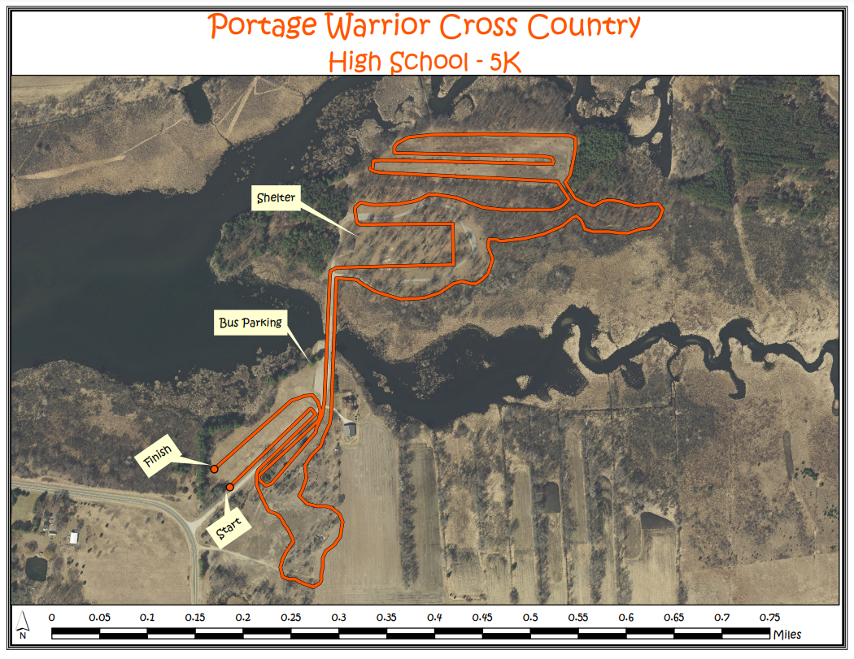
Course Map

