43rd Annual Port Washington Invitational
DATE: | Thursday October 5, 2023
SITE: | Tendick Nature Park. Located 2 miles north of Saukville on County Highway O.
PARKING: | All buses will park inside of Tendick Park. All spectators must park on the other side of the road in a remote lot and take the shuttle bus or walk to the course. The County has posted “NO PARKING” signs along the road and will enforce these no parking zones. Please inform your spectators.
COURSE: | Course is mostly open prairie with a small patch of woods with a wood chip trail. Spikes are recommended. Both the boys and girls will race 5000m. Maps of the course have been attached with the email and more will be available when you arrive.
STARTING TIMES: | 4:00 - Boys JV  4:30 - Girls Varsity - Can run up to 8 - the eighth runner does not push.  5:00 - Boys Varsity - Can run up to 8 - the eighth runner does not push.  5:30 - Girls JV  There will not be an Awards Ceremony. Coaches should pick up awards after the meet at the Pavilion.
AWARDS: | Plaques - to first and second place varsity teams  Trophy - to first place JV team.  Varsity - Medals for 1-20.  JV - Medals for 1-5
ENTRIES: | The scoring of all four races will be done by Trackside Timing.  Entries will only be accepted online through MileSplit Wisconsin  - Coaches can access on-line entries directly at wi.milesplit.com or at www.tracksidetiming.com  - NOTE: Instructions for first-time account set-up and registration are posted at www.tracksidetiming.com. Plan accordingly and give yourself at least 48 hours to create your account and upload your roster.  - The meet is titled “Port Washington Invite” in wi.milesplit.com. Log in to your account and find the meet in the calendar. All entries submitted by Tuesday, October 3, at 8:00 PM.  - Meet information, start lists, and results will be posted at www.tracksidetiming.com
TEAMS(Box#): | Beaver Dam 3, Brookfield East 11, Cedar Grove-Belgium 15, Cedarburg 9, Fond du Lac 7, Germantown 5, Hartford 16, Neenah 8, Ozaukee 6, Plymouth 2, Port Washington 1, Sheboygan North 13, Sheboygan South 12, Slinger 4, West Bend East 14, Whitefish Bay 10
T-SHIRT SALES: | Port Washington Invite T-Shirts will be available for $20 at the Pavilion. Design on the next page.
CONCESSIONS | Concessions will be available throughout the meet under the Pavilion.
**Please encourage your spectators to carpool. Limited parking available, shuttle bus will be provided.**
Sincerely,
Mark Pasten - PWHS Boys Coach - 262.268.5616- Office or mark.pasten@pwssd.k12.wi.us
Joe Adamak - PWHS Girls Coach - joe.adamak@pwssd.k12.wi.us
John Bunyan - PWHS AD - 262.268.5511 or john.bunyan@pwssd.k12.wi.us

2023 Port Washington Invitational Course Map

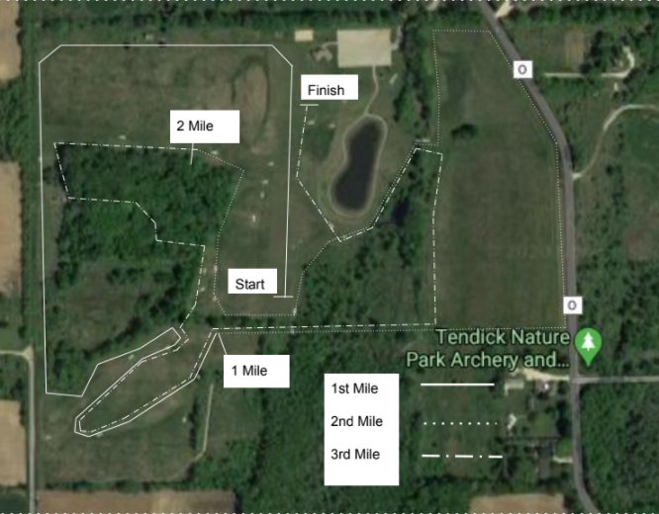
2023 Port Washington Invitational T-Shirt Design

